THESIS OF

Food For You


Thesis submitted for the partial fulfilment of the
requirements for the award of the degree of
Bachelor of Science in Software Engineering (Morning)
at the University of Sindh Jamshoro.

By
 | Aqib Mughal | 2k17/SWE/14
 | Muazzam maqbool | 2k17/SWE/52
 | Siddique Siyal | 2k17/SWE/126

Supervisor
Dr.Kamran Taj Pathan
Associate Professor IICT

December 2020

Dedicated to

This project is outcome of great dedication and support of our teachers, friends, colleagues, family and our project supervisor. We have done team work dedicated time, knowledge and money, but without the support of these people we had not achieve this goal.

So we will proudly dedicate this project to all these people for their support and trust on us.

Certificate
For

IICT Resource Management System
Submitted by
 | Aqib Mughal | 2k17/SWE/14
 | Muazzam maqbool | 2k17/SWE/52
 | Siddique Siyal | 2k17/SWE/126
For the partial fulfilment of the
requirements for the award of the degree of
Bachelor of Science in Software Engineering (Morning)
at the University of Sindh Jamshoro.
Supervisor | Thesis Committee
Co-Supervisor | Final Year Projects’ Committee Head
Final Year Projects’ Coordinator | Director IICT

Abstract

IICT Resource Management Information System is a set of software components that intend to provide management to Campus teachers and other staff of IICT to efficiently use the campus resources without the smallest of possibilities of dead lock situation. IICT Resource Management Information Systems focuses on the management of information systems to provide efficiency and effectiveness of strategic decision making to spread out the resources when needed.
This MIS is particularly designed for Department of IICT University of Sindh Jamshoro to automate the resource management system to functional use

Acknowledgements

First of all we will thank Almighty Allah who gave us strength to work and achieve this goal, by his grace we were able to get this opportunity.
After that we are thankful to family, friends, teachers, project supervisor and all those peoples who supported us in different stages.

List of Figures
Figure 1 1
Figure 2 4
Figure 3 6
Figure 4 7
Figure 5 7
Figure 6 8
Figure 7 8
Figure 8 9
Figure 9 9
Figure 10 13
Figure 11 13
Figure 12 14
Figure 13 14
Figure 14 15
Figure 15 15
Figure 16 15
Figure 17 16
Figure 18 17
Figure 19 18
Figure 20 18
Figure 21 19

Contents

Chapter No. 1 Introduction 1
1.1IDEOLOGY 1
1.2 MOTIVATION 2
1.3 CONTRIBUTIONS OF THE THESIS 2
Chapter No. 2 Background and Literature Review 4
2.1 Environment 4
2.2 New Environment 4
Chapter No. 3 TOOLS AND TECHNOLOGIES 6
3.1 PLATFORMS & TOOLS 6
3.1.1 HTML5 6
3.1.2 CSS3 7
3.1.3 Bootstrap 7
3.1.4 asp.net 8
3.1.5 adobe illustrator cc 2019 8
3.1.6 visual studio 2019 9
3.1.7 sql server & ssms 9
3.2 FUNCTIONALITY 10
3.2.1 How the Procedure Works 11
Chapter No. 4 Conclusion and Future Work 20
4.1 FUTURE DIRECTIONS 20
4.1.1 Advantages 20
4.2 CONCLUSION 20
References 22

List of Abbreviations
HTML  CSS  FFY  SSMS  RDMS |  | Hypertext Markup Language  Cascading Style Sheet  Food For You  SQL Server Management System  Relational Database Management System

Introduction
In this chapter we are sharing the journey of this project from its ideology, motivation, contributions and the structure of whole project.

Figure No: 1

IDEOLOGY
As we are watching everything is going towards digitalization in today’s world and everything is available online, so the idea of this project came by an ideology to give a platform to all those people who want to sell the food online because everyone can't open restaurant so they will have opportunity to have a business online. As well as all those people who loves the food will have an platform to buy, taste various types and variety food items, give ratings and comments to particular food chief's.

1.2 MOTIVATION
Motivation, this thing came by the idea which we decided to fulfill that we can also create an opportunity a platform for those who wants to run the business. So that thing motivated us that we can at least give our small contribution to all those peoples who already have skills but needs a platform. As a Software Engineering student we thought it would be great to show our skills and learning’s in this thing. So we came up with great motivation to our supervisor.

1.3 CONTRIBUTIONS OF THE THESIS
Food for you is perfect. The one more thing which makes it perfect is Thesis of FFY. The contributions of thesis have its own importance in FFY project. Because it show the dedications, hope, hard work, team work, and all the up’s and down’s which occur during this project.

1.3.1 OVERVIEW

One of the contribution is that you can find out the history of our research that when all this started. How the idea came, what were the steps which we used to fulfill this project.

1.3.2 FIND HOW PROJECT WORKS
Next contribution is that you can easily operate this project. All the steps, all the tools, functions & procedures are written in thesis in very easy & understandable language.

1.3.3 PLATFORMS WHICH ARE USED
You can have the idea’s regarding changing, updating this software in the future according to your comfort, because these all tools, functions, platforms & the background structures are written in the thesis.

1.3.4 CORE OF RESEARCH SUMMARIZED
All the conclusions, summary of our research and implementation are easy to find in this thesis.

Background and Literature Review

In this chapter we present that how these types of projects works according to the environment. The history of these tools, platforms etc. Many of the sellers in market gives management software’s but we are sharing this with upgraded & innovative solutions & features.

2.1 Environment
When we compare the environment so we can easily find out that this environment is totally change from the previous one. Back then there was no this type of platform facility for online food business. Many difficulties were faced by people to buy and sell the food. Both side peoples had different issues. In older environment if someone wanted to sell food they should have their own shop or restaurant to sell it, same as it is if someone wanted to buy the food so they had to go to shop or restaurant to have food.

2.2 New Environment
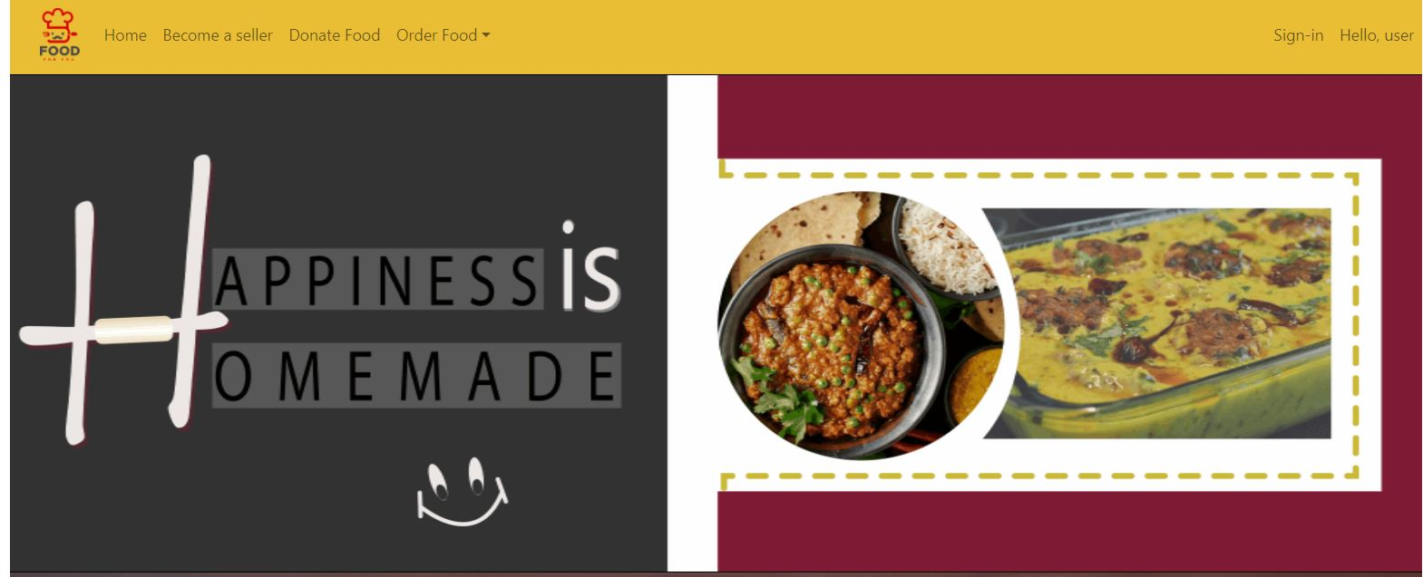
Figure No: 2
Food For You is digital online platform which is suitable for people who are foodie or who wants to run their business. It can give a proper platform and opportunity as well. This online application is designed for buying and selling food online, give reviews, suggestions and ratings. It generates business opportunities, time saving & money savings platform. The users can make profile, review food, have an eye on their favorite restaurants and many more options which are briefly described in chapter no 3.

TOOLS AND TECHNOLOGIES
This chapter is core of the thesis, because this chapter include the tools, background platforms, technologies, features, functions, and steps that how this management system works.

PLATFORMS & TOOLS
In FOOD FOR YOU we have used different platforms, some are for the front-end designing some are for the back-end which helped us to do the operations with the database side. These platforms & tools are as follows.

3.1.1 HTML5

Figure No: 3
We have used HTML5 for our project. Because our project is a web based project so we have used this platform like a backbone. HTML 5 is updated version of HTML. And this was the best option we had for our project.

3.1.2 CSS3

Figure No: 4
When we talk about HTML so there is always one thing which comes with it and that thing is known as CSS. Because without CSS HTML is like a house without any paint on it. Again we have used updated version of CSS for better experience and to give attractive look to our web application.

3.1.3 BOOTSTRAP

Figure No: 5
Bootstrap is a Framework used for building the responsive webpages. So we chose this platform to work on our web application as our management system application is also responsive so this was the best option to work on.

3.1.4 ASP.NET

Figure No: 6
ASP.NET is developed by Microsoft. This frame work was very important for us as we were making a web application. This frame work works smoothly, more efficient and it is easy to use. It works to develop web applications. So that’s why we chose this framework.

3.1.4 ADOBE ILLUSTRATOR CC 2019

Figure No: 7

Adobe illustrator is a designing software by Adobe. It is used to design the logo, icons, drawings, sketches and many more thing. It has very powerful tools and functions which help in making creative things. It is widely used by Graphic designer all over the world. We also needed to make the logo, banners, menu and icons for our website, so we thought this software would be very good platform to work on and then we started working on it and it helped us a lot in designing work.

3.1.5 VISUAL STUDIO 2019

Figure No: 8

Visual Studio is an IDE platform from Microsoft. Programmers and developers use it to develop computer programs, websites, web applications, mobile apps and web services. It’s functionality to make GUI applications, websites are easier to learn and very professional to execute which gives very good results. This thing attracted us and of course it was our need so we chose this platform for developing FFY.

3.1.6 SQL SERVER & SSMS


Figure No: 9
SQL Server is a platform which is developed by Microsoft. It is a RDMS (Relational database management system). The main function of SQL Server is to storing and retrieving data requested by the software applications. Which anyone can access it doesn’t matter that from where the user is requesting for data it can be from same device or it can be over the network anywhere from internet. So because of its reliability we chose to work on SQL Server 2019 updated version to store our database of FFY. Now to manage the SQL Server we needed a platform to manage it. So we go for the SSMS option which stands for SQL Server Management System. This application was developed to configuring, managing and doing administrative functions on Microsoft SQL Server.

FUNCTIONALITY
FOOD FOR YOU is a web application that have provided an opportunity to both sellers and buyers. In this web application of FOOD FOR YOU platform we have different profiles and their functionalities. Each profile have a different procedure to do their work. There are two types of these profiles for two types of peoples, both of them have different buttons, pages, and functionalities. In these types one is for the users who will buy the food items and the other one is for those who will sell their food items.

3.2.1 How the Procedure Works
Food Customization
Website
Take Away
Home Delivery
Order
Desi Food
Fast Food
User
Seller
Sign In
The user will access the website after that he/she should make an account to login and to use the functionality like buying the food or selling the food item. He/she will go to signup page make an account for them. There are two different account types, one is for the food buyer’s and second one is for the Chefs who will sell their food items. While making the account they will give their basic identity data like Full name, Contact number, address, email address(for future advertisement). After giving personal details they will set up their username and password and they will make a profile according to their use if the user is buyer he/she will register the account and start using it but if the user is seller he/she will have an option to update their food items in given forms, which include the food item ID, name and price. After setting up their profiles they can login to their account. A buyer or seller can see the menus of food items available in the website after that they can place an order according to their need and a chef can update their items more details of their roles are in 3.2.2 section. There are different stages and procedures that a user will go from in FOOD FOR YOU as shown in above image.

3.2.2 ROLES

There are different categories which we have made in this website to entertain all the users who will visit FFY. Each category have its own roles and limitations which will be applied when a user will create an account on our website. They can use and get entertain according to their account category which they have made during signing up in FFY. We have two categories in FFY.

- Buyer
- Chefs

- BUYER

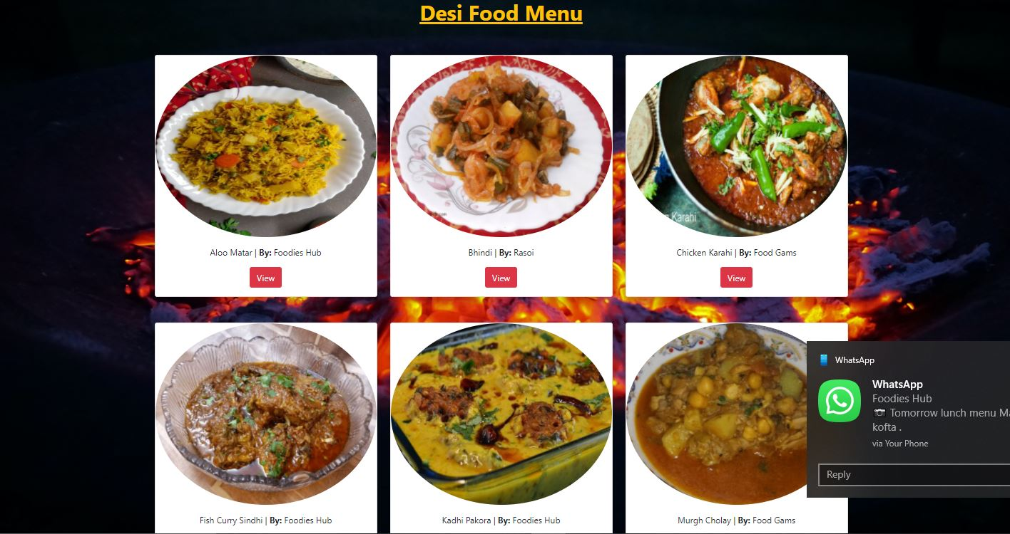

Figure No: 10

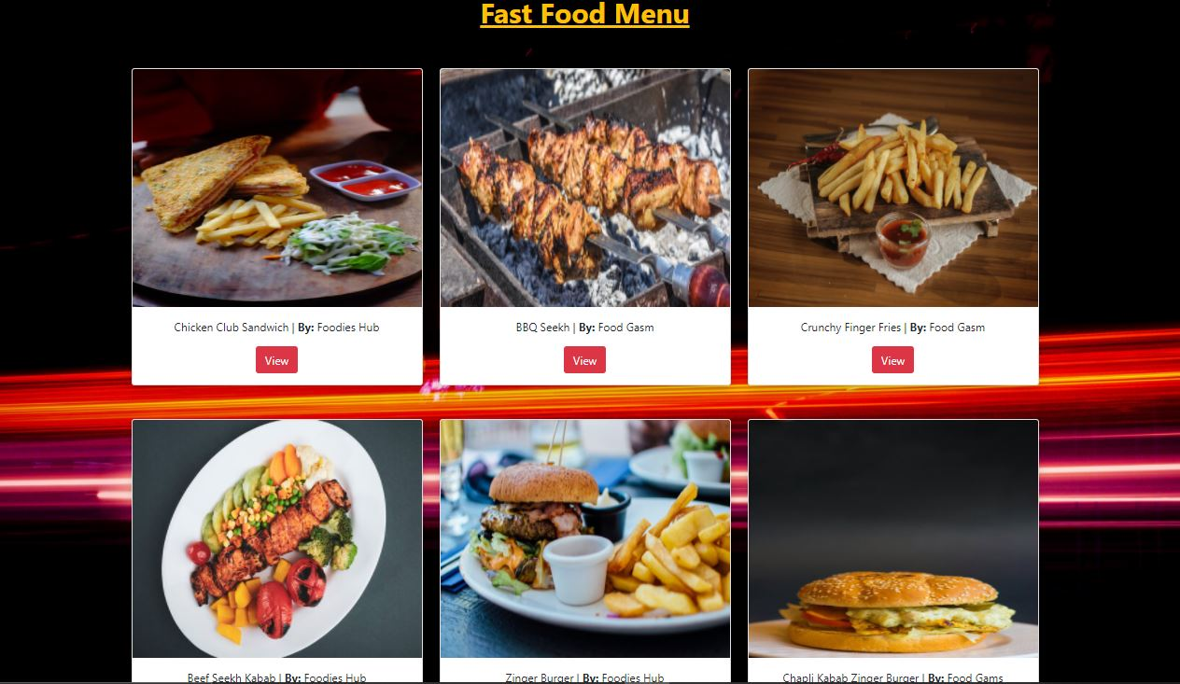
Figure No: 11

As show in above images a buyer can see food items menu according to their taste. They can also select their favorite food, restaurant or chefs. And they can also see the prices of food items buy clicking on view button. A user can see separate menu pages according to type of the food it has separate menu page like desi food items, fast food items etc.

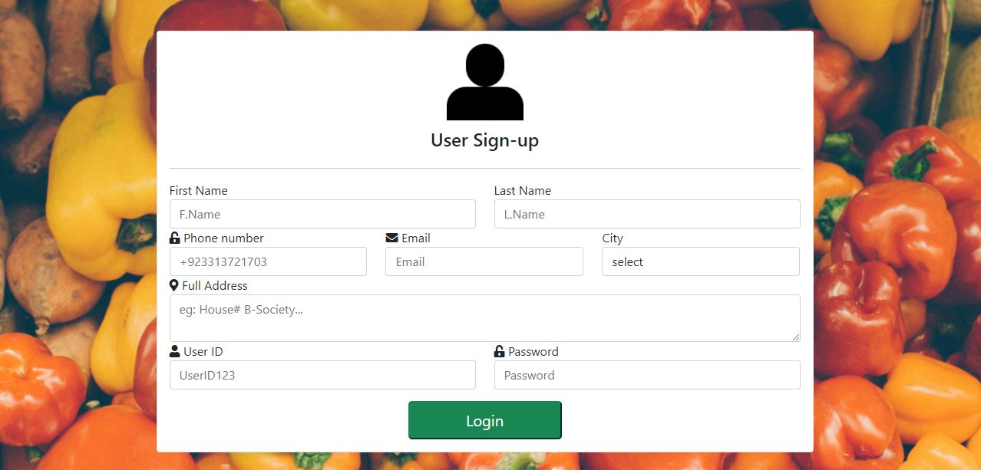
Figure No: 12
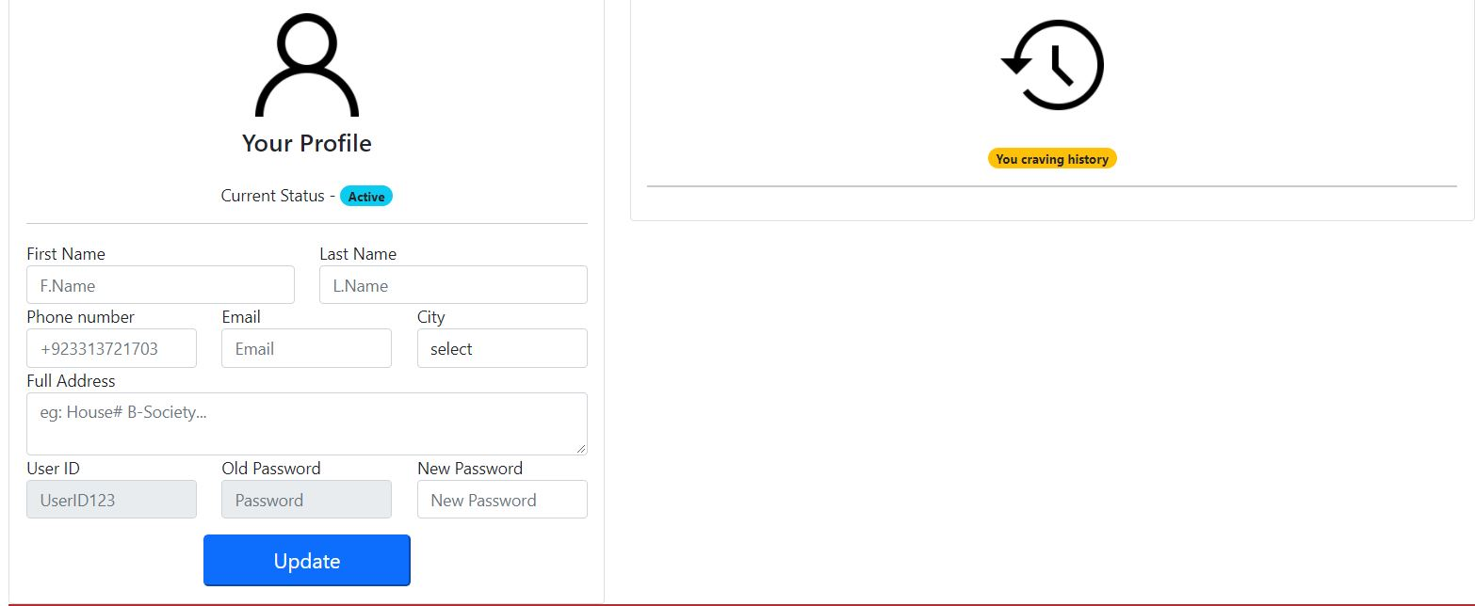
Figure No: 13

They can create or login to their account can set up their profile and adding the details like Name, Phone Number, Email, City and Address. And they can also see their history of ordered items.

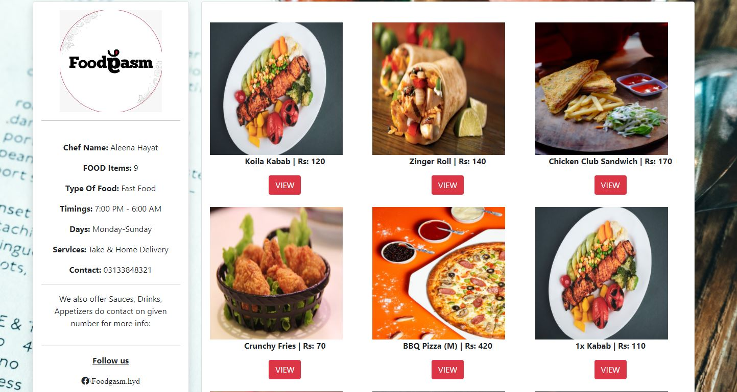
Figure No: 14

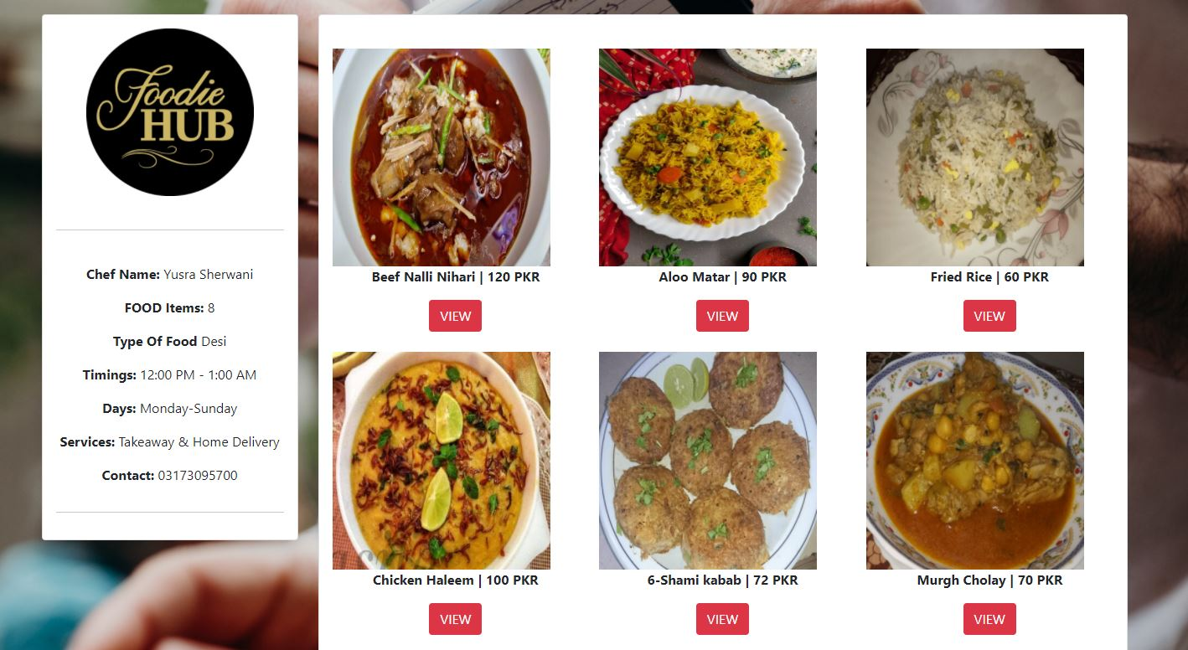
Figure No: 15

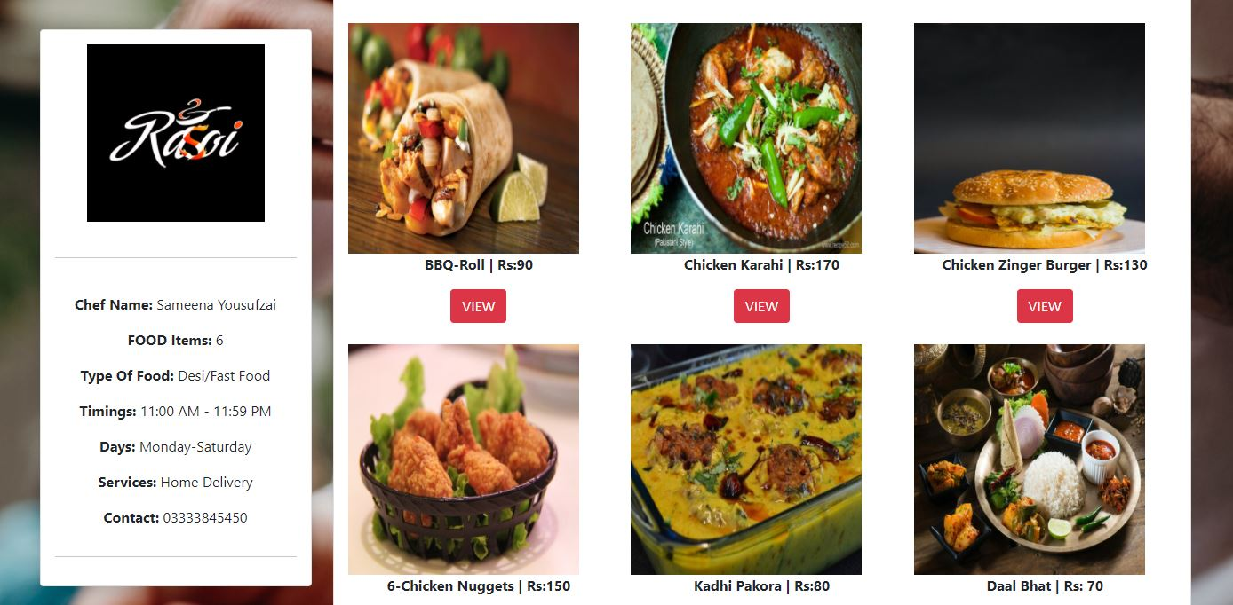
Figure No: 16

They can also see individual their favorite restaurant, chef’s profiles in which they can see their food items. For viewing that page they will have to go to menu page where they can see all the listed food items and the name and price which will be mentioned below the images of the food. There a small button will be shown of VIEW through which they can go to the profile page and there they can see all the further details of the food and chef’s profile as well.

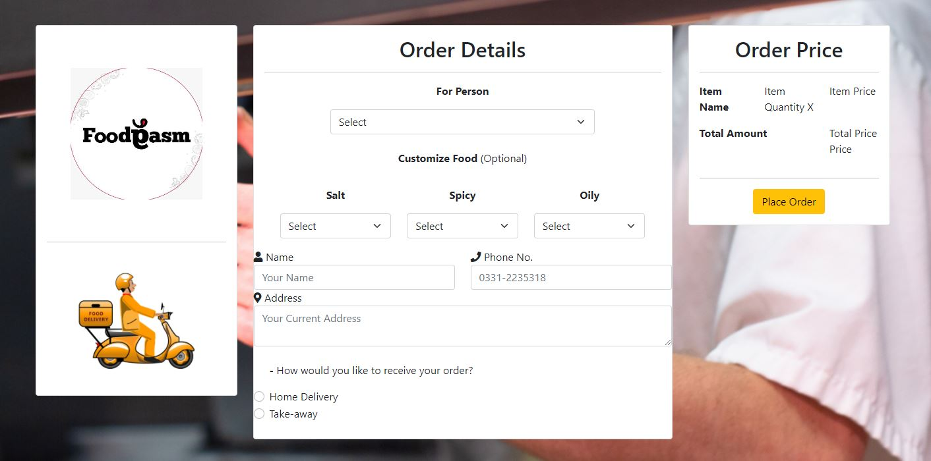
Figure No: 17

They can order their food item by filling up a proper form in which they will select the persons means quantity of the food, after that they can also select they spices, and oil level in their food. After selecting it they will mention their name, phone number for contact and address. They can also select they option of ordering food at home or take away service, after filling up the form they will see their details and amount of food items (like a bill), there they can place their order by clicking Place Order button.
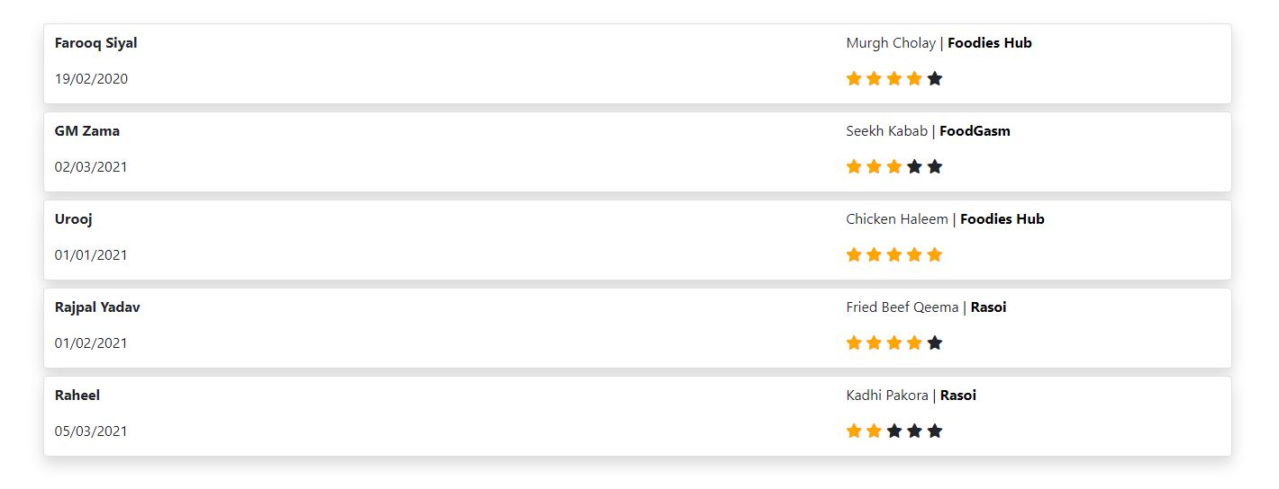
Figure No: 18

A buying user can give the ratings and reviews about the website and the restaurant services food quality and they can give them ratings according to their services and food. Which will help other buyers that which restaurant’s food or service is better. As well as the sellers can also see this ratings page that who have given them ratings and which rank they are at, so that they can do improvements in their food quality.

- CHEF

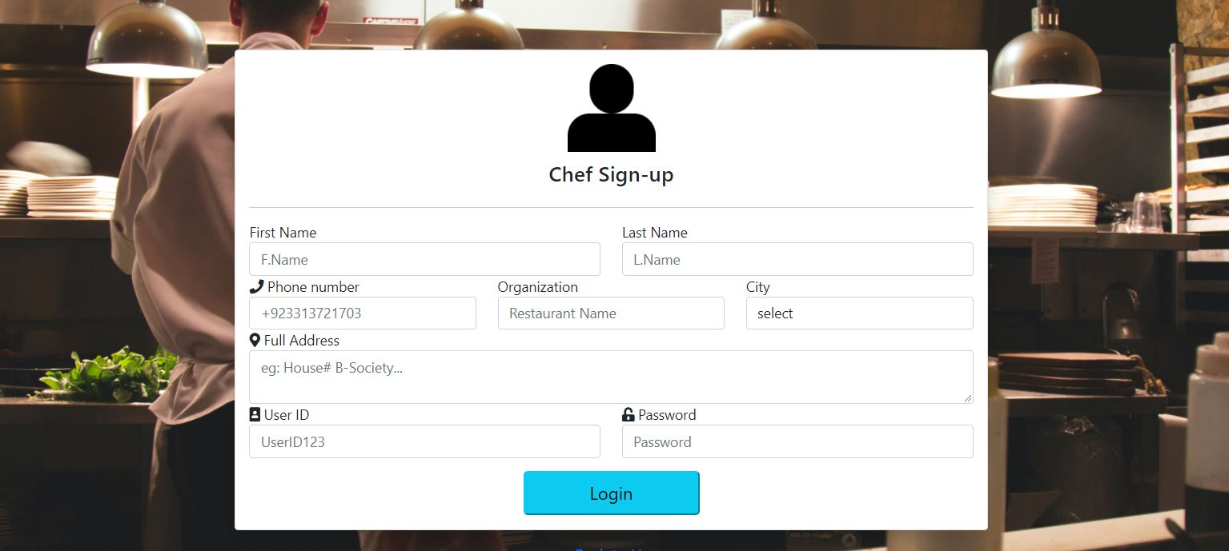
Figure No: 19

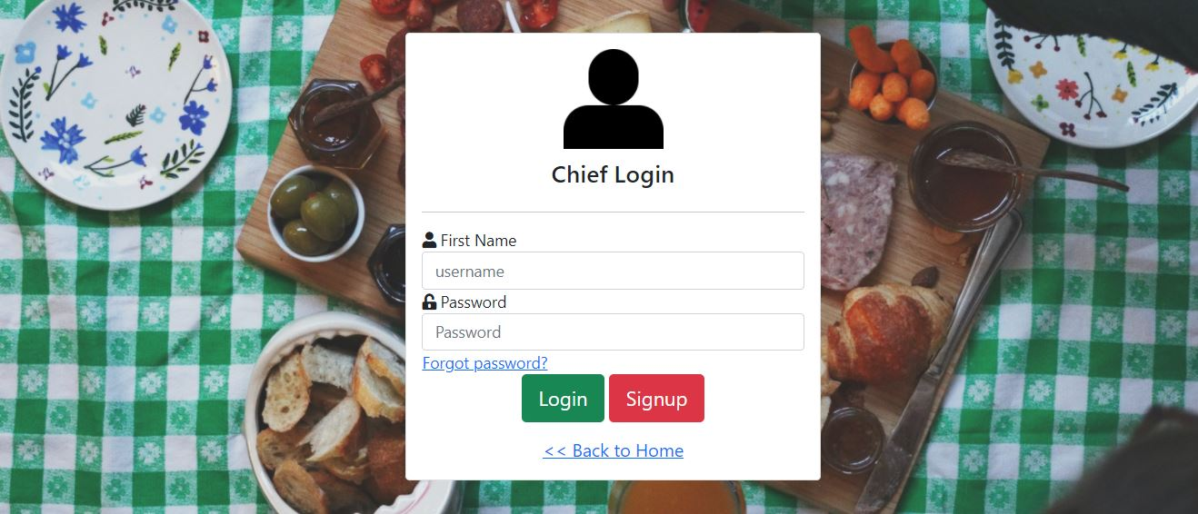
Figure No: 20

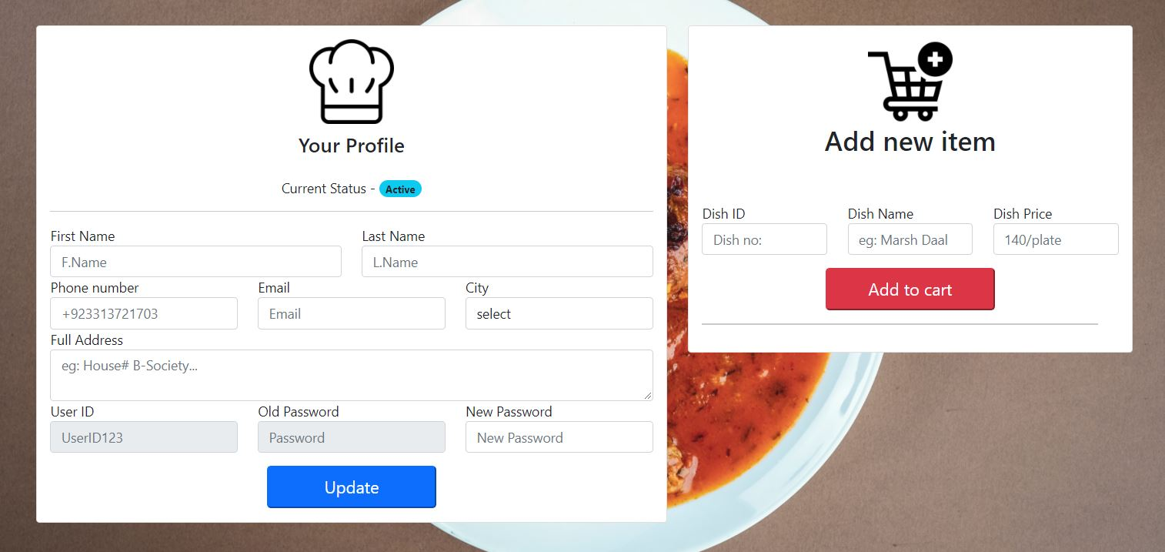
Figure No: 21

A chef or seller can make an account and sign in and create their profile in which they will add their details like Name, phone number, address. They can also add their food items while creating the account which include Item name, ID, and its price, they can add various food items. And like a normal user they can also see the food menu of their own food items and others as well they can also see their own ratings and reviews to make their selves more perfect. There is update option available which they can use to update their profile details

Conclusion and Future Work
In this chapter we will discuss about the outcomes, future advantages, comparison and conclusion.

4.1 FUTURE DIRECTION

The impact of FOOD FOR YOU will increase day by day because as we all can see the world is going to digitalization now days everyone wants each and every thing to be done in comfortable way, so this idea will grow faster and will give an opportunity to those who wants to eat their favorite food at home. As well as all those who have skills of cooking they can start their business at their house. So it will have a positive impact and people will definitely use this platform. People will also love this idea because today people face many problems to order the food online they have to go on different platforms like social media, search engine websites to take out their favorite restaurants contact number or address and the new beginners who want to enter in this business they usually don’t have any type of platform to advertise their food items, that’s why their business don’t work and they stop that thing. By our idea and implementation of this FFY web application everyone can access it

4.1.1 Advantages

There are many advantages of this project.

Will give a platform to start a business.

Will give a comfort to all those people who likes to enjoy outside food at their home with their families.

Will save the time and efforts to go outside and buy the food.
- Easy to understand the procedure, and easy to use.

4.2 CONCLUSION

The aim of this project was to facilitate the people who wants to buy food and also those who have skills of cooking and want to start a business form their homes. So with this idea we thought to make it more efficient and modern so we decided to make a web application so everyone can access it and enjoy the facilities. And we succeed to make FOOD FOR YOU.

References
[1] www.google.com
[2] www.youtube.com

